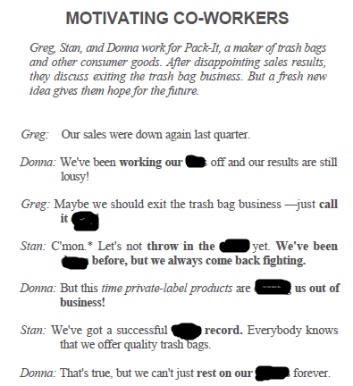

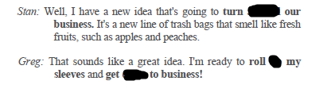

**around, down , up , laurels, track , driving , towel , down , quits , tails ,**

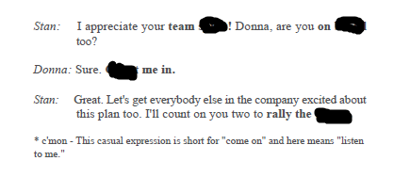

**board , troops, count , spirit ,**